|  |
| --- |
| **IT Project** |
| Synoptic Assignment – Section A Version Control |
| Checkpoint 3 – Creating a commit in a GitHub repository using GitKraken  By Matthew De Giorgio BAN 6.3A |
|  |

Contents

Preface 1

Step 1 2

Step 2 3

Step 3 5

Step 4 6

Step 5 8

Step 6 9

# Preface

Once Gitkraken detects changes in the filesystem of the repository, automatically it will prompt the user to make a commit.

# Step 1

For this exercise, a sample file system used for a typical assignment was created within a new repository hosted on Github.

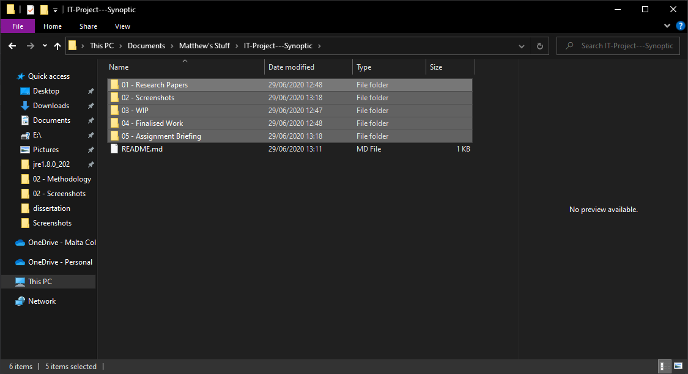

# Step 2

Returning to Gitkraken, one can see the interface that is used when a registered repo is selected.

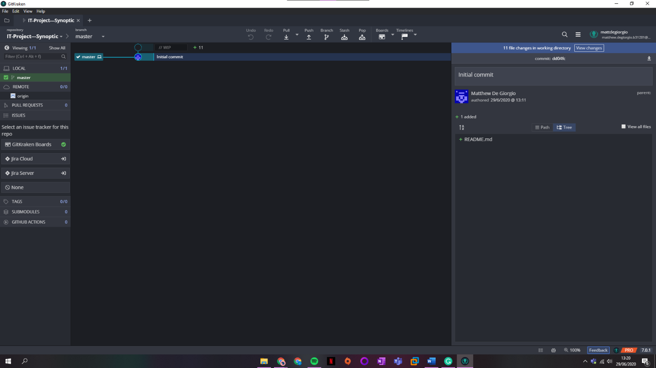

Once changes are made to the working directory, two things happen:

1. In the central tree view, a **//WIP** ghosted commit is shown.
2. To the right, a message pops up showing the amount of files changes detected.

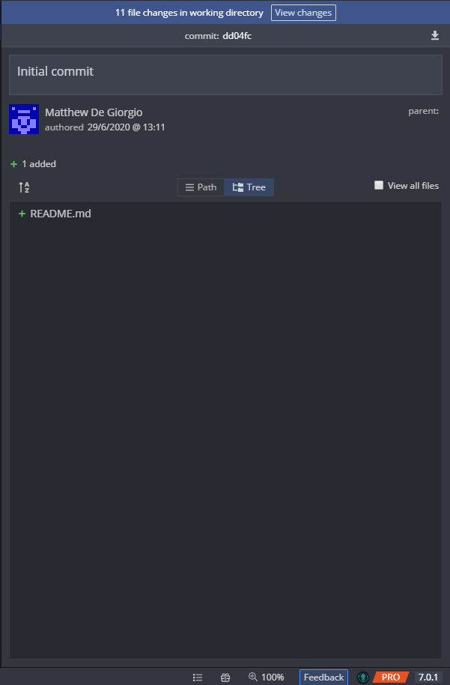

# Step 3

Clicking on the **View Changes** button brings up a new right interface with 3 main sub-sections.

The top section allows the user to navigate and view the new/amended files.

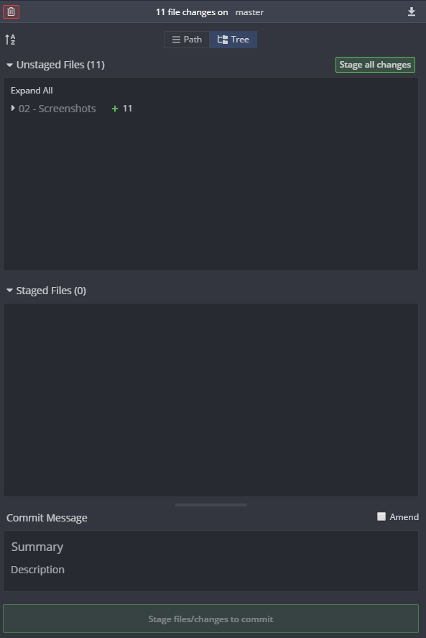

# Step 4

When viewing single files, the user has the option to stage the file or stage all changes from the right interface. Gitkraken supports all major file formats.

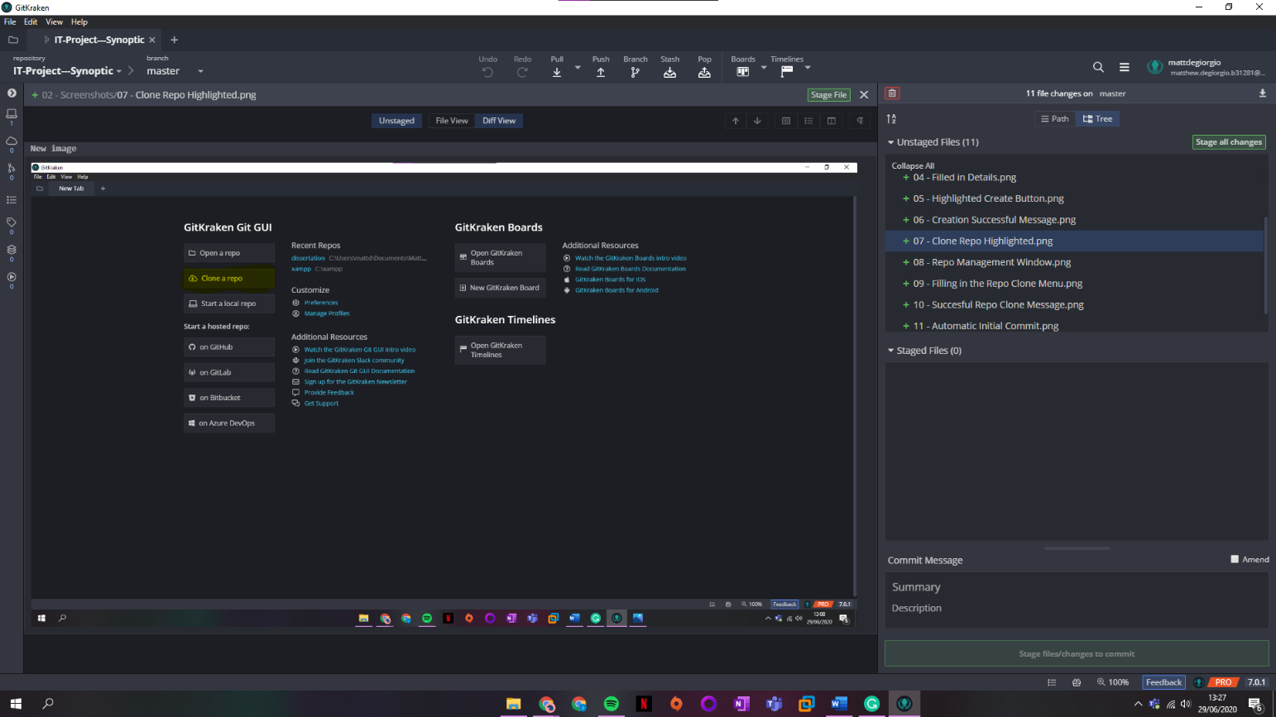

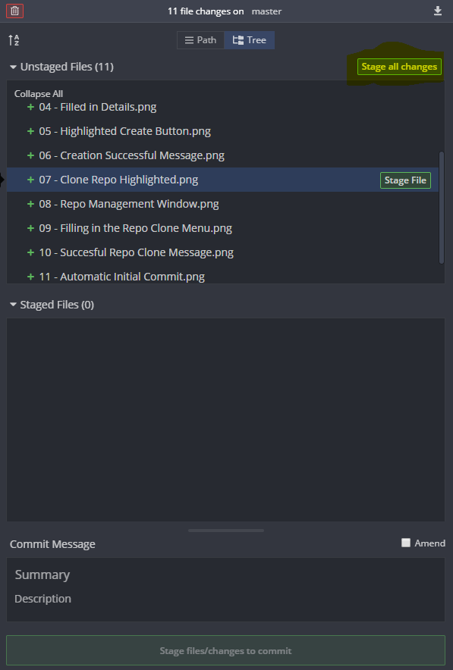

All the screenshot being added with this commit.

# Step 5

Once the files have been staged, the user can navigate through them once again and unstage the particular file or unstage all the files and changes for that commit.

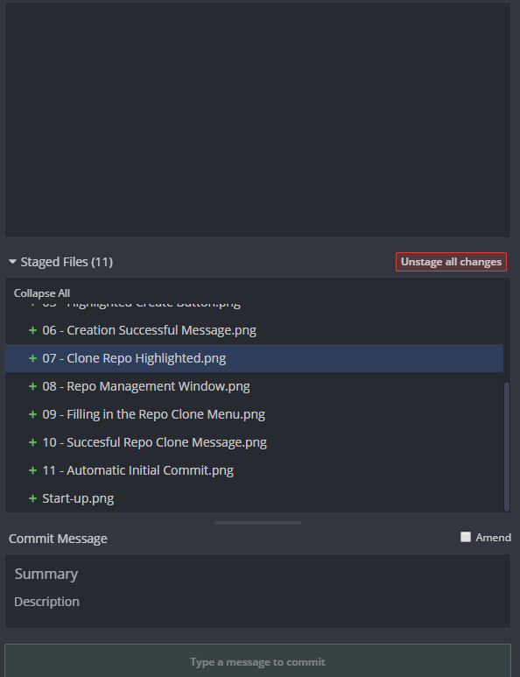

# Step 6

In the commit message section, one finds fields to give the commit a summary and a description. Fill in the fields and click the Commit button.

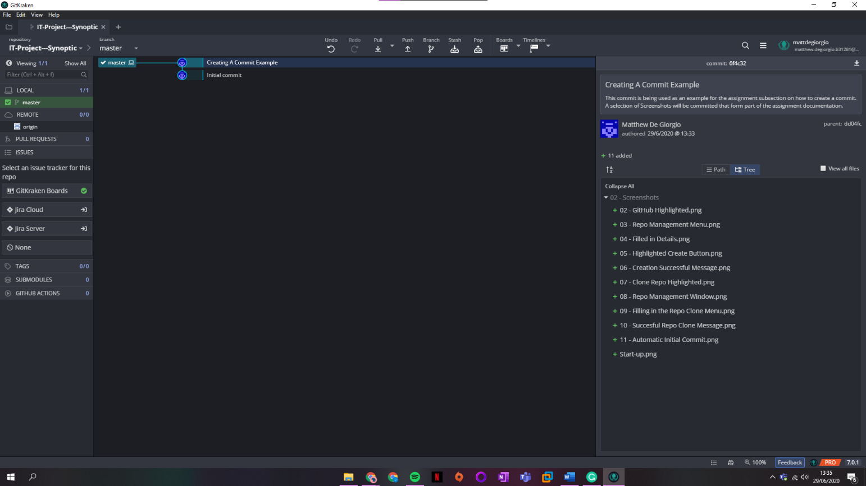

Going back to the main repo interface, we can see the commit was created. To the right, we can see a breakdown of the commit, the commit code, summary, description, and the changes applied.